PHILIPPINE
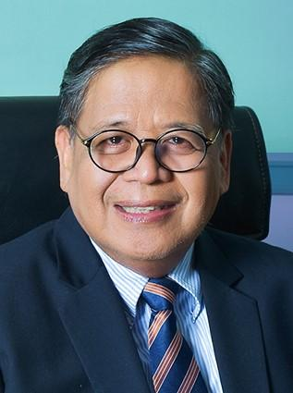
Judge Benjamin Turgano (Ret)
President, Wesleyan University

TAIWAN

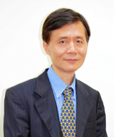
Dr. In-Ming Lee
President, Chung Yuan Christian University

TAIWAN
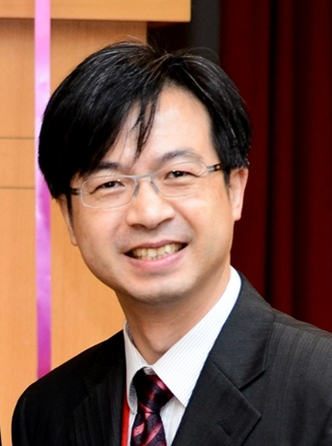
Prof. Ta-Chin Wei

